02458 Cognitive modelling E19

1st Assignment

Adrian Atienza (s192780)

Arianna Taormina ([arita@fysik.dtu.dk](mailto:arita@fysik.dtu.dk))

Marie Claire Capolei ([macca@elektro.dtu.dk](mailto:macca@elektro.dtu.dk))

Maud Leclerc (s191975)

# Part 1: Psychophysics

1) First we calculate the perceived brightness using Steven’s law

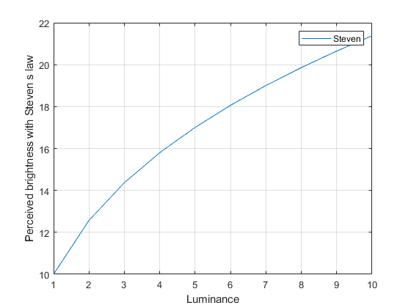

2) Then we implement Fechner Law in our code, for both Luminance input and electroshock input, and compare it to Steven´s.

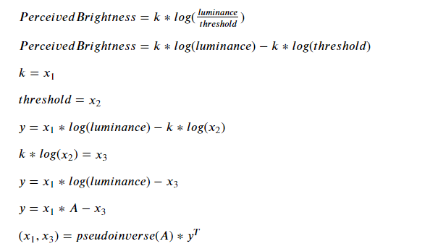

3) We fit Fechner’s law to the data, getting the two parameters k and the threshold as solutions of linear system in this way:



Comparison Stevens and Fechner for Luminance data

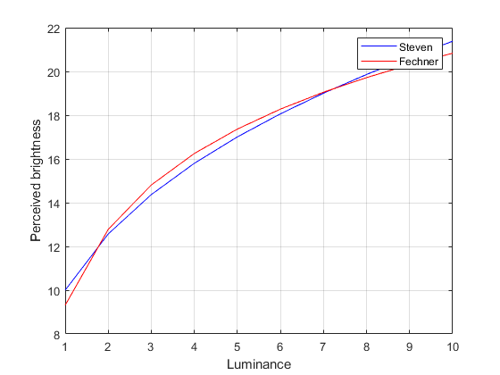

Comparison Stevens and Fechner for electric shock data

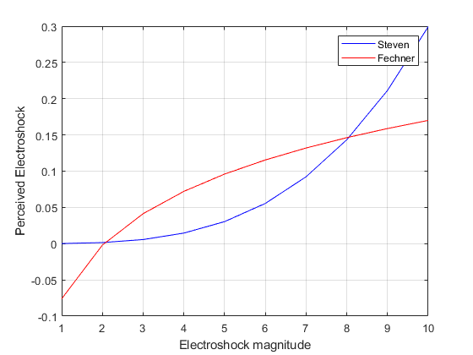

As expected, Fechner law is able to predict the perceived brightness quite well: the results of experiments on luminance conducted for over a century were confirming its validity.

More recent experiments on electric shocks showed that, in all reality, the connection between intensity of the stimulus and its perception is not logarithmic, but exponential (?)/power of x (?). As it is shown in the last graph.

# Part 2: Signal detection

## 1) SN and N equal variance

We build our Noise (N) and Signal+Noise (SN) Normal equal variance distributions as follows:

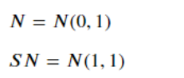

Noise is set with mean 0 for convenience. Signal+Noise is therefore set with mean 1, as the distance between the two curves is: d’ =1

We run 3 experiments of 100 trials each. From now on, we will refer to SN as “signal” for simplicity.

In the proposed tests, 50% of the trials come from the N noise vector, and 50% come from the SN noisy stimulus vector.

In the experiments, the criterion of the observer varies between lax (the observer is more keen to say ´yes I saw the signal’), moderate (we choose the tradeoff between the N and the SN, aka the point where the curves meet), to conservative (the observer is more keen to say ‘no I haven´t perceived the signal’).

The change of criterion in real experiments can be accomplished in many ways: from changing the proportion of input/no input in the trials (prior probability of Signal or No Signal, of which the test subjects are informed), to add a payoff or a punishment (were the test subject will have to find the best strategy to optimize their gain).

For each criterion the applied procedure is the following:

1. Count the numbers of Hits (H), Miss (M) on the simulated signal.
2. Count the numbers of False Alarms (FA) and Correct Rejections (CR) on the simulated noise.
3. Get the experimental probabilities and standardize them.
4. Get an estimation of the d’ from the standardize probabilities.
5. Compute d’ as

d' = zN-zSN = zP(hits) - zP(FA)

The number of H Hit, M Miss, FA False alarm, and CR correct rejection for each criterion and the corresponding experimental probabilities are listed in the tables below.

In the third table, the initially assumed d' is compare to the experimental d’ (d_prime_approx).

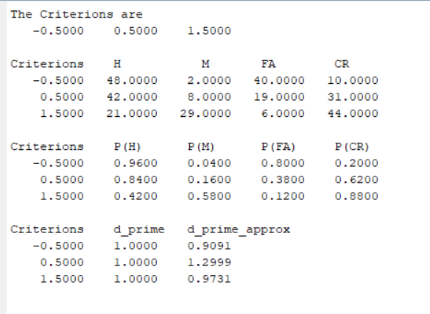

The results show that d’ approximation is close to the real d’. From additional tests, we notice that the quality of the approximation improves with increasing number of trials, for instance for t = 1000 trials there is no large deviation between the approximation of each criterion.

We deduce that the approximation of d’, or rather the observer capability on distinguishing two different stimulus, is not highly affected by the Criterion if there is large number of experimental data available. d’ is an index of detectability of the input and it is defined as sensitivity and can be seen as the distance between the mean values of the two normal curves.

We plot the ROC in Gaussian coordinates and fit the equal variance model to the data. Is the fit reasonable?

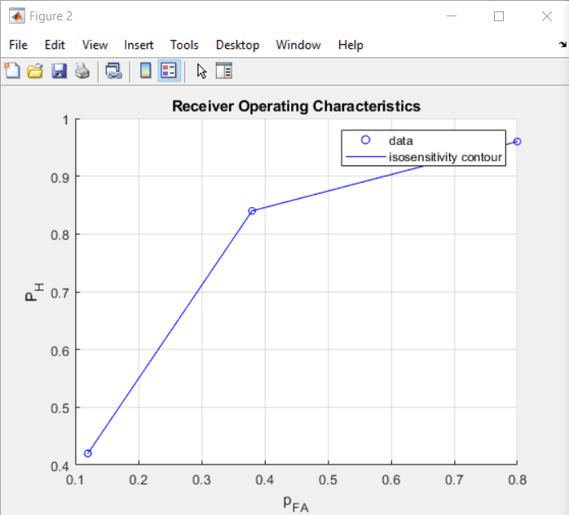

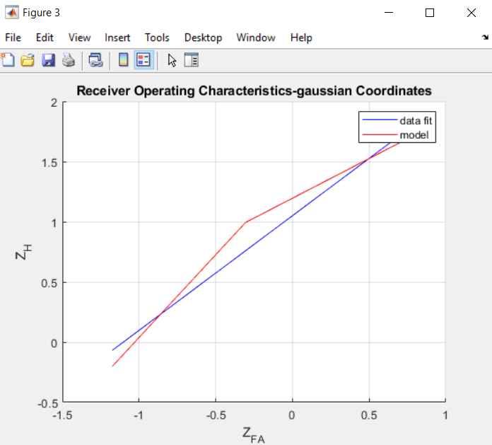

We find a single estimate of *d’* from the fit using the ROC applying

d’= z_H + C

We can see that the d’ values remain relatively invariant when estimated with different methods.

## 2) SN and N unequal variance

We build our Noise (N) and Signal+Noise (SN) as Normal distributions. The Noise distribution is kept constant with respect to the previous experiments, while the signal mean and variance are changed.

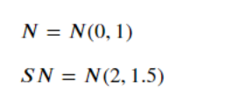

We update the criterion to be C = [-0.5 0.8 1.5]

We then estimate *d’* for an unequal variance observer in the 3 experiments with different criterions.

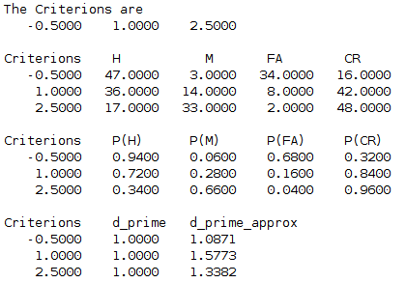

We can observe that d’ as previously defined is not constant along the ROC curve, meaning that it varies for different criterion values.

Other values might be used as measure of detectability for normal distributions with unequal variance: delta_m, d_e’, d_a, proportion of area under the ROC curve. This last one is particularly handy because its interpretation doesn’t depend of the underlying distributions of N and SN and because it doesn’t necessarily need curve fitting to be calculated (ROC curves are very fitted to straight lines as can be seen from figure below).

Roc curve:

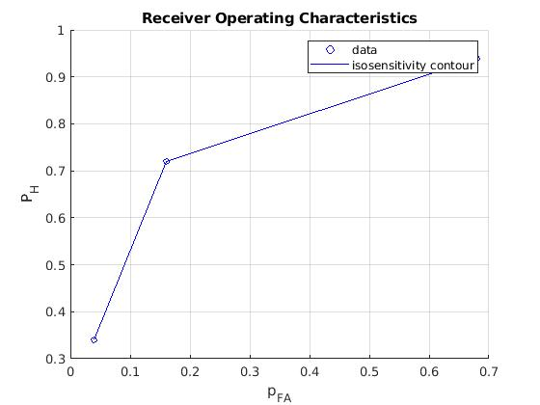

The slope of ROC curves tells us about the variance of SN and N. If the slope= 1, we fall back in the previous case of equal variance, if the slope is <1 then the variance of the SN is greater of the variance of the noise N.

We plot the ROC in Gaussian coordinates and fit the unequal variance model to the data.

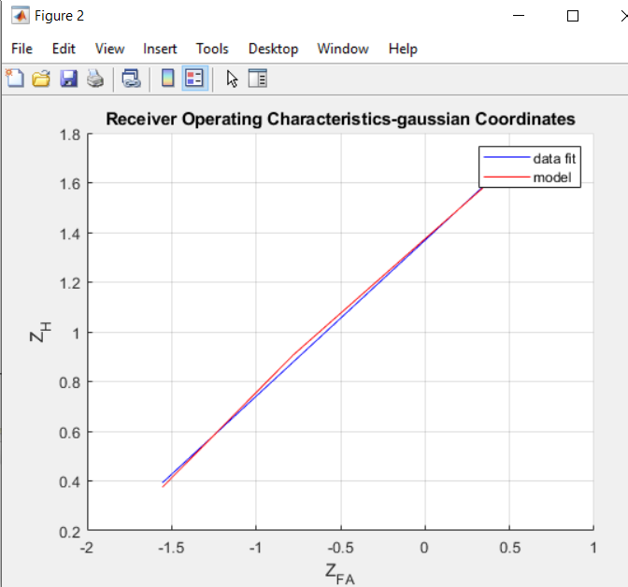

As for the equal variance distributions, we can define:

z_H = (1/ std_SN)* z_FA + (µ_SN/std_SN)

Where z_H and z_FA are the z scores of the probabilities P_H and P_FA.

From our fitting we got the parameters y_fit = P(1)*x + P(2)

Running the code for 100 trials we get:

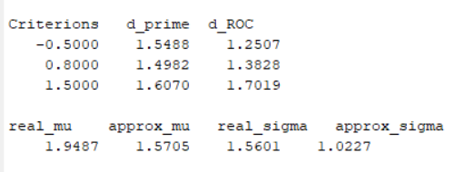

Which gets even better with 1000 trials

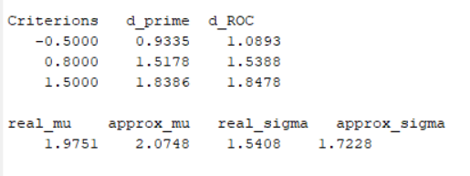

# Part 3: Psychometric function

1) Fit the psychometric function to the data using a squared error function. What are the estimates of its parameters?

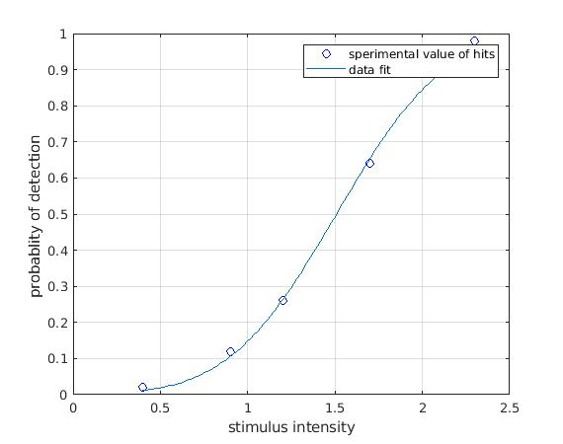

The above figure illustrates how the estimated model fit the experimental data. The estimated parameters of the cumulative gaussian probability function are:

µ = 1.5075 ; std = 0.4853

In the second part of the experiment inputs are given with intensity 1 or 2. To evaluate the sensitivity of the observer we can calculat the area under the ROC curve, using the cumulative gaussian function that we have defined: Fcb (@ B, x).

We find:

Fcb(B,1) = 0,14 ca

Fcb(B,2) = 0,84 ca

We can say that the observer has a lower sensitivity to the less intense stimulus and a much higher sensitivity to intense stimuli.

"In a follow-up experiment we use only intensity levels 1 and 2. The task of the observer is to say whether the intensity level is ‘high’ or ‘low’. What value do we expect for the sensitivity (d’)?"